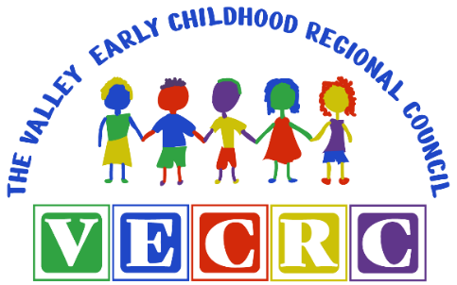

**Valley Early Childhood Regional Council Meeting Agenda**

**February 9, 2023**

**9:00-11:00 am**

**Virtual Meeting via Zoom**

<https://us02web.zoom.us/j/88409835979?pwd=clhISFdiQXgreUNXcGJ4TzhnM21QZz09>

*Welcome

*December 8, 2022 Meeting Minutes

*Regional Budget Discussion-Carissa Caserta/Mary Sue Feige

*Naugatuck Valley Health Department-Carissa Caserta

*Valley Childhood Poverty Reduction Collective Impact Initiative (VCPCI) Update-Dr. Peg Oliveira

*OEC/Liaison Updates-Ayanna Williams/Diana Brancato

\***Program/Agency Sharing:**

* School Readiness Providers
* Valley Regional Adult Education
* Child First
* Other

**Next VECRC Meeting: May TBD, 2023**

***Please feel free to share the VECRC website link with Valley families ☺ ***

[www.vecrc.org](http://www.vecrc.org)

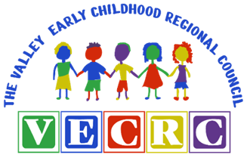

**Valley Early Childhood Regional Council Meeting Agenda**

**December 8, 2022**

**9:00-11:00 am**

**Virtual Meeting via Zoom**

***Mission: To support the Valley Community as a leader in early childhood development and family engagement in an effort to ensure all Valley children are prepared socially and developmentally to thrive in school.***

**Welcome and Introduction**

**December 9, 2022**

|  |  |  |
| --- | --- | --- |
| **Council Member Name** | **Email** | **Affiliation** |
| Carissa Caserta | ccaserta@nvhd.org | NVHD/Co-Chair |
| Mary Sue Feige | msuefeige@seymourschools.org | Seymour Schools/Co-Chair |
| Ayanna Williams | ayannawilliams127@yahoo.com | Derby/Seymour Shelton SR Liaison |
| Diana Brancato | dbrancato@ansonia.org | Ansonia SR Liaison |
| Dee Kopec | kopecs@att.net | Mayor Designee- Shelton |
| Alison Conway | aconway@derbyps.org | Superintendent Designee- Derby |
| Krissy Warranger | kwarranger@derbynecklibrary.org | Librarian- Derby |
| Courtney Sherman | csherman@bhcare.org | Healthcare Provider |
| Linda Flach | lflach@lnvpcrc.org | Healthcare Provider |
| Reese Morales | amorales@ansonia.org | McKinney-Vento Liaison- Ansonia |
| Barbara Eckner (Resign) | beckner@cccymca.org | Provider- Ansonia and Derby SR |
| Shannon Bullard | sbullard@juliadaynursery.com | Provider- Ansonia SR |
| Alyson Stanisci | astanisci@teaminc.org | Provider- Ansonia and Shelton SR |
| Tracy Platt | tplatt@ansonia.org | Provider- Ansonia SR |
| Elizabeth Heon | kidsclub@sbcglobal.net | Provider- Derby and Seymour SR |
| Rebecca Verdicchio | rverdicchio@sheltonpublicschools.org | Provider- Shelton SR |
| Kristen Ezzo | kristenfinocchiaro@gmail.com | Parent |
| Keely Edwards | kedwards@derbyps.org | Derby Schools |
| Cathleen Kellett | ckellett@griffinhealth.org | Community Rep. |
| Debra Hansen | dhansen@vrae.org | Community Rep. |
| BJ Hornby | bjhornby@att.net | Community Rep. |
| Laura Harris | Laura.harriscc@gmail.com | Community Rep. |
| Catherine Pomeroy | cpomeroy@derbyps.org | Community Rep. |
| Lauren Reid | lreid@seymourschools.org | Community Rep. |
| Ryan Leworthy |  | Valley YMCA |
| Shannon Levey | leveys@seymourct.org | Seymour Parent/BOE |
| Alison Brett |  |  |
| Val Di Gangi |  | Valley Community Foundation |
| Dr. Joseph DiBacco |  | Ansonia Superintendent |
| David Morgan |  | Team President |

**Motion to Approve the Minutes from December 8, 2022**

**Dee – First; Keely-Second – all in favor**

**Welcome and Introductions- Carissa Caserta**

Carissa called the meeting to order and introductions were made.

In Attendance:

|  |  |  |
| --- | --- | --- |
| **Council Member Name** | **Email** | **Affiliation** |
| Carissa Caserta | ccaserta@nvhd.org | NVHD/Co-Chair |
| Mary Sue Feige | msuefeige@seymourschools.org | Seymour Schools/Co-Chair |
| Ayanna Williams | ayannawilliams127@yahoo.com | Derby/Seymour Shelton SR Liaison |
| Diana Brancato | dbrancato@ansonia.org | Ansonia SR Liaison |
| Dee Kopec | kopecs@att.net | Mayor Designee- Shelton |
| Joseph DiBacco | jdibacco@ansonia.org | Superintendent- Ansonia |
| Alison Conway | aconway@derbyps.org | Superintendent Designee- Derby |
| Courtney Sherman | csherman@bhcare.org | Healthcare Provider |
| Linda Flach | lflach@lnvpcrc.org | Healthcare Provider |
| Reese Morales | amorales@ansonia.org | McKinney-Vento Liaison- Ansonia |
| Barbara Eckner | beckner@cccymca.org | Provider- Ansonia and Derby SR |
| Shannon Bullard | sbullard@juliadaynursery.com | Provider- Ansonia SR |
| Tracy Platt | tplatt@ansonia.org | Provider- Ansonia SR |
| Elizabeth Heon | kidsclub@sbcglobal.net | Provider- Derby and Seymour SR |
| Rebecca Verdicchio | rverdicchio@sheltonpublicschools.org | Provider- Shelton SR |
| Kristen Ezzo | kristenfinocchiaro@gmail.com | Parent |
| Debra Hansen | dhansen@vrae.org | Community Rep. |
| Laura Harris | Laura.harriscc@gmail.com | Community Rep. |
| Alison Brett | abrett@seymourschools.org | Community Rep. |
| Catherine Pomeroy | cpomeroy@derbyps.org | Community Rep. |
| Rebecca Gardner | rgardner@bhcare.org | Healthcare Provider |

**Regional Budget Discussion- Carissa Caserta/Mary Sue Feige**

The budget as of 11/30/22 is $8643.11 as of 2/9/2023.

[**Minutes**](https://docs.google.com/document/d/1H-nDpo4oLiT1QShwji0GjHQiPiPTxB18/edit?usp=sharing&ouid=104577981175663960685&rtpof=true&sd=true) **from October 13, 2022 Meeting**

Mary Sue Feige made a motion and Linda Flach seconded to accept the minutes from the October 13, 2022 meeting. All were in favor with no opposition so the motion carried.

**Naugatuck Valley Health Department- Carissa Caserta**

Carissa reported that Covid cases are going up. Ansonia and Shelton are the highest in the ages of 0-19 years old. NVHD is working on scheduling flu shots for families that are having difficulty getting them at the doctor’s office. The NVHD is reminding everyone of the importance of handwashing and keep your child home if sick. RSV infections are back. We expected this to happen. Check expiration dates of the test kits.

Linda Flach asked if people weren’t getting the flu shot. Carissa said that a lot of people are testing positive. From a parent perspective, hard to get a flu shot for the kids—delay in being able to get an appointment, nice that the NVHD is offering the flu shot.

**OEC/Liaison Updates- Ayanna Williams/Diana Brancato**

The Liaison Report was provided prior to the meeting. In summary, Ayanna and Diana shared the following:

* ECE Reporter and monthly reports updates. The OEC has transitioned the management of ECE Reporter from Skylight to the OEC.
* Wage Supports for Early Childhood Educators- This is a two-phased initiative for all School Readiness staff in licensed and license exempt programs.
* The OEC released Enrollment Grant applications to School Readiness funded sites late October. Providers completed the application to attest that their enrollment was a minimum of 50% of families at or below 300% of the Federal Poverty Level.
* Change in weeks of operation- School Readiness programs have been required to be open for at least 50 weeks/year since the grant originated in 1997. OEC has recently changed this requirement to where programs must be open 48 weeks with individual days of closure not being counted.
* Infant and Toddler Expansion spaces- this funding is intended to provide low-income Connecticut families with increased access to high-quality, affordable infant and toddler care in licensed facilities. TEAM applied for 6 CDC slots in phase 1 and were awarded. VECRC School Readiness programs currently do not have capacity to expand within their programs to create new I/T spaces. Ayanna and Diana will be submitting an opt-out application, via Qualtrics.
* Ayanna and Diana will be conducting their second round of FY23 monitoring consisting of the Professional Registry check (Staff qualifications, DQSM compliance, licensing and accreditation status, Registry updates and reporting requirements), in-person Classroom Observations of Large Group Time, review of School Readiness and Parent Fee Budget Expenditure Reports and a review of School Readiness student Attendance Reports. Each program will receive a summary report and action plan if needed-will share with governance committee.
* Diana loves being back into programs and classrooms. It has been a nice opportunity especially with new staff and supporting them. Kudos to our programs! Since it is a state funded grant, our programs are held to a high standard. The program directors are keeping a great job with their plan of study and how their staff is being supported. They are staying on top of that.
* Ayanna mentioned the scheduled provider meetings that were conducted. They met with Ansonia, Derby, Shelton and Seymour providers. Discussed highlights, parent engagement, hearing screenings, professional development, ECE, updates, and challenges.
* Ayanna discussed CES presenter, Suzanne Clemente, to speak with activities and professional development. All programs will get 1:1 coaching and work with lead teachers. Excited that teachers are going to get that support.
* Diana discussed Suzanne’s previous presentations, and how grateful we are for the Enhancement monies for the programs.

**Program/Agency Sharing:**

**School Readiness Providers:**

Tracy- *Ansonia Public Schools* has 50 Full Day/Full Year slots and 10 Part Day/Part Year slots and all 50 FD/FY and 10 PD/PY slots are utilized. Tracy shared on the following Quality Components:

|  |  |
| --- | --- |
| ***Quality Components*** | ***Implementation*** |
| *Parent Involvement (Family Engagement)* | *Lisa Perrotti, our Family Support Specialist, arranged a “Male Empowerment Night” which included dinner and a presentation by one of our male preschool teachers from the program. The event encouraged the fathers or father figures of our students to get to know one another and share parenting stories and advice. There were 18 total participants with which provided positive feedback and requested that it be done again!* |
| *Health (record-keeping policies and referrals)* | *We are in the process of collecting proof of flu vaccination from all students. Lisa Perrotti set up an on-site Pre-k flu clinic through NVHD on 11/2 to help families obtain their vaccinations by the deadline of January 1, 2023. WE currently have 20 students who have yet to complete the vaccination.* |
| *Annual Evaluation* | *We received our NAEYC Assessment visit results in July. We passed with very good scores! Individual classroom scores ranged from 90% -98%. The Program Portfolio score was 99.19% and the Program Observation score was 100%. This process of preparing for the visit encouraged me to update and/or create new policies and procedures and as a result, was an improvement of the entire program.* |

Shannon- *Julia Day Nursery* has 23 Full Day/Full Year slots and all 23 FD/FY slots are utilized. Shannon shared on the following Quality Components:

|  |  |
| --- | --- |
| ***Quality Components*** | ***Implementation*** |
| *Parent Involvement (Family Engagement)* | *We held a trick or treat event where 35 families attended. We also invited families into the classroom to read or share about their job or hobby. We had parents in for Pie the Wednesday before Thanksgiving. We also conducted a family survey to see what types of events they would like to see. We are planning a Gingerbread House building, a group for Paw Patrol, Harlem Globetrotters, and the Bridgeport Islander, a parent and me paint night at the Giggling Pig, and a slime day at the Vault Virtual Reality.* |
| *Nutrition* | *The SNAP Ed office was at the center sharing information with families about SNAP benefits as well as healthy recipes they can make with their family and some shopping trip tips to promote healthy eating.* |
| *Professional Development* | *We attended 2 school readiness trainings one on making a referral and the other on SRBI. We also held a professional development day for our staff on 11/4. Our education consultant did a training on strategies to support challenging behaviors. We also did our Annual OSHA training, had DCF come in for a training and completed our CPR and First Aid renewal.* |

Diana shared on behalf of Aly Stanisci- *Lower Naugatuck Valley EC Ed (TEAM)* has 18 ANSONIA Full Day/Full Year slots and all 18 FD/FY slots are utilized. SHELTON has 10 Full Day/Full Year slots and all 10 FD/FY slots are utilized. The following Quality Components were shared for Ansonia and Shelton School Readiness:

|  |  |
| --- | --- |
| ***Quality Components*** | ***Implementation*** |
| *Pre-Literacy (teacher training)* | *Teachers participated in a literacy training focused on connecting the development of literacy and social-emotional skills.* |
| *Nutrition* | *We have partnered with a new catering company who is providing more variety and better quality menu items.* |
| *Admission policies that promote diversity* | *While TEAM’s admission policies have remained, we dedicated a day of professional development to focus on diversity, equity and inclusion in the classroom.* |

Barbara- *Valley YMCA Child Care Center* has 22 ANSONIA Full Day/Full Year slots and all 22 FD/FY slots are utilized. DERBY has 7 Full Day/Full Year slots and 7 slots are utilized. Barbara shared on the following Quality Components:

|  |  |
| --- | --- |
| ***Quality Components*** | ***Implementation*** |
| *Parent Involvement (Family Engagement)* | *Staff are using the CT DOTS Family Pages to gain family input to inform staff what families see their children doing at home. These pages also give families information regarding how they can help their children grow in specific areas of development.* |
| *Professional Development* | *Staff completed two trainings related to Serving Children with Special Needs. These trainings were focused around referrals and supporting the needs of ALL learners through an SRBI process.* |
| *Sliding Fee Scale* | *The new sliding fee scale has been implemented with new families who recently enrolled in the program.* |

Liz- *Kids Club* has 13 SEYMOUR Full Day/Full Year slots and 9 slots are utilized. DERBY 6 Full Day/Full Year slots and 1 slot is utilized. Liz shared on the following Quality Components:

|  |  |
| --- | --- |
| ***Quality Components*** | ***Implementation*** |
| Family Literacy | *We are continuing to invite families in to read to the children during story time. We have had a great response. The children love having their mom, dad… in the classroom.* |
| Professional Development | *We are working with GEER with the online DOTS system.* |
| Annual Evaluation | *We did one last program evaluation with staff and families as we enter into candidacy for NAEYC, to see if we are meeting the expectations from the previous survey.* |

Rebecca- *Shelton Public Schools* *Mohegan* has 22 Part Day/Part Year slots and 22 slots are utilized. Shelton Public Schools Long Hill has 23 Part Day/Part Year slots and 23 PD/PY slots are utilized. Rebecca shared on the following Quality Components:

|  |  |
| --- | --- |
| ***Quality Components*** | ***Implementation*** |
| Transition to Kindergarten | *Once a month Preschool teachers and Kindergarten teachers have a building* *wide meeting where they are given an opportunity to collaborate and exchange resources and materials.* |
| Professional Development | *We have planned for all teachers to attend an entire day of required PD in February. They have also had 3 Pd’s on Ct SEDS and Ct DOTS.* |
| Sliding Fee Scale | *We have been working on collecting and verifying income for all families in our program.* |

**Valley Regional Adult Education (VRAE):**

The VRAE Report was shared prior to the meeting. Debra Hansen discussed how they are getting their students into programs, scholarships, and employment. They did a bus trip to Gateway. They continue to grow. Once they become English proficient or graduate, they move on to next steps.

Diana asked if there are larger groups from different countries? Deb said there are more Ukrainians. There is a variety, ESL program is very diverse. Families are bringing over families. The VRAE biggest section is beginners with no English or computer skills. Ayanna asked about staffing. Deb mentioned they are good with staffing.

**Child First:**

The Child First Report was shared prior to the meeting. Courtney Sherman shared they are recruiting for a clinician. She discussed the role of the care coordinator and the clinician, behavior, trauma, and work with parents on their own history and impact on the child. They are serving 12 families, with a waitlist of 15 families. Funding comes from DCF. If there is active DCF involvement, you can bring it to Courtney. Courtney discussed they have not had any applicants in the area.

**Other:**

* Diana discussed the in-person Kindergarten registration Ansonia is planning to bring back this coming year at the end of March.
* Reese Morales asked everyone on the council to let him know about sharing clinicians or if they can help in anyway. He also reported that a Dr. Martin Luther King celebration will be held at Ansonia High School. Tickets are $20 with student performances. There will be baskets and raffles. It will be an amazing event!
* Ayanna promised to share the Shelton Plumb Library calendar of activities with the council on behalf of Maura Gualtiere.

**Adjournment**

**Next VECRC Meeting: February 9, 2023 9:00 a.m. - 11:00 a.m.**

***Please feel free to share the VECRC website link with Valley families ***

[www.vecrc.org](http://www.vecrc.org/)

**Regional Budget Discussion-Carissa Caserta/Mary Sue Feige**

The budget as of 11/30/22 is $8643.11 as of 2/9/2023. TEAM is the fiduciary for the VECRC. TEAM is the fiduciary for the VECRC. New website-have to auto-renew – working with TEAM on that amount.

**Naugatuck Valley Health Department-Carissa Caserta**

**Test kits shipment are available as needed. Contact NVHD or Carissa; Respiratory illnesses are on the decrease. January expiration test kits are good until April.**

**Valley Childhood Poverty Reduction Collective Impact Initiative (VCPCI) Update-Dr. Peg Oliveira**

**Val-discussion of project: back in 2016 Community Index-poverty rate for kids 8-12 was at 26%; by 2019-went up to 27%; poverty rate increasing – develop a model to bring together Childcare providers, parents, stakeholders, and look for ways to bring the povery rate down. Found 1400 kids 0-5 who were experiencing poverty with families; surveyed parents in 2020 – two major reasons: lack of affordable and high quality childcare and community resources- met wit Dr. Peg Olivera to see what we can do- there are several alternatives we can do to address this in the valley; we went back out into the community-Peg is going to show you what she learned-we need to be able to look at alternatives we can look at together;**

**Dr. Peg Oliveira – Director of Giselle University at Yale University – summary of research – Val has a recording of all the research—feel free to come back to Val or Peg; summary – some of the models in our research:**

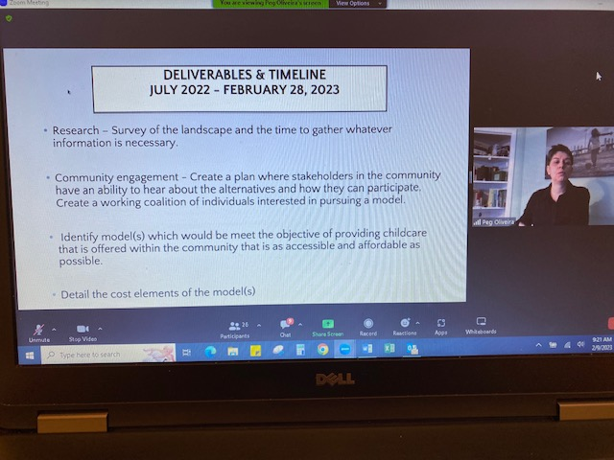

**Worker – Owner model – employees benefit from profits-stake in the business**

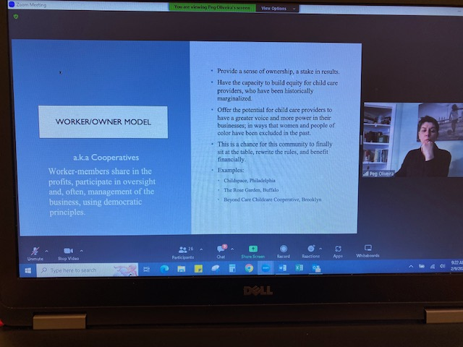

**MicroCenters-Hubs (co-working spaces) – a central hub or centralized back office to support business that enables providers to focus on childcare – not in the home but in a business**

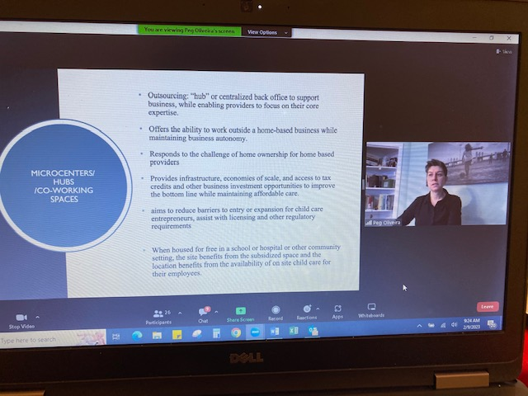

**Shared Services – allows individual programs to stay small - autonomy to own your own site; group purchasing power – maintaining independence business – various sites come together and have a subsidiary manager**

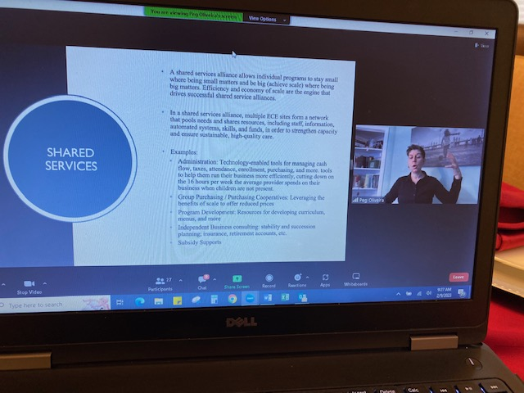

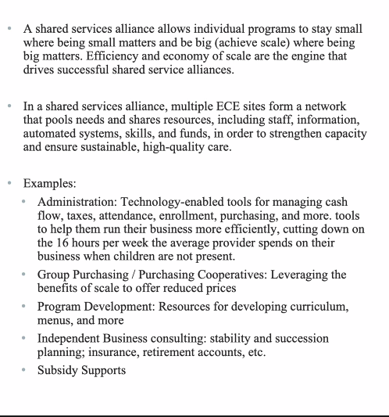

**Housing Supports for Child Care Providers – seen in New Haven - buying houses, individual apartments, and living in the houses with families, pets, yards…they are given financial advisers to identify their goals, debts, savings for the future**

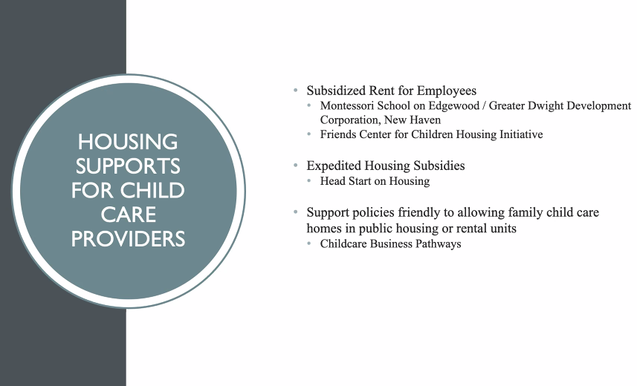

**Head Start has had housing subsidy – a fast pass to get to the housing subsidies**

**Utilize time to support policies; bill being proposed to change rules around what landlords can say/can’t do around childcare**



**Retention of staff; Care for Kids access**

**PowerPoint and recording can be sent out to the group;**

**Peg Oliveira - What will work in your community?**

**Linda Flach – Is there a model that jumps out at you? –How does a Montessori and Friends program provide families homes, this is an underpaid career?**

**Peg Oliviera-Friends Center took this approach-found big donors-$500,000 – house was purchased and now it is upkeep; Montessori has state funding with additional support; There needs to be an influx of funds from somewhere else.**

**Carissa – shared resources can work well in this community**

**Peg Oliveira - What will be the challenges/barriers?**

**Shannon Bullard – if there is a hub, there may be transportation issues; some walk to a center**

**Questions/Confusions?**

**David Morgan – meaningfully involved in this work; barrier will be capacity – dedicated champions who can implement these recommendations; if and when we have dedicated people we can do this; keep this work on the agenda (the Foundation); the reality is that there is no public investment in this work – and childhood workers pay; we need a national investment; two key outcomes – increase supply of childcare and entrepreneurship – personal self-sufficiency and increasing access to infant and toddler care;**

**Val Di Gangi – equity piece; Is there a way to do more than one model. This work has been on everyone’s plate. As David said, it took the pandemic to amplify this (childcare). Can we do hybrid?**

**Peg Oliveira – Many overlap and can put them in other models. You really want to know what your families are interested in. You don’t want to build an amazing site without knowing your community and what they are interested in. What best serves infants and toddlers? Is there a need for more centers? What are they willing to do or not do? All these models are being utilized somewhere; what is the fit for your community?**

**Diana Brancato - discusses the community events in Ansonia - to have smaller conversations with parents in all the communities**

**Val Di Gangi - discusses Naugatuck and TEAM—will be looking at other opportunities; short window of time for Peg – looking at providing opportunities/next steps**

**Peg Oliveira – will speak to groups that are currently meeting**

**Dr. Reese Morales (Ansonia) – we look forward to having you.**

**Val – If there is interest, let her know, and we can work with Peg on next steps for the other valley communites**

**David Morgan – Parents are the experts; how do we get them to be meaningfully involved that can move childcare - what is needed and what do they want; Governor has put the parent cabinet in his budget.**

**David Morgan: Recommendation – keep childcare on the agenda – there is progress—you need to know where it is**

**OEC/Liaison Updates-Ayanna Williams/Diana Brancato**

**Ayanna Williams – Review of updates. Received a link on January 9th, providers can login to OEC – working on it to make enhancements to reports, input data…**

**Diana Brancato – discussion of the enrollment grant; OEC grant being offered for 23-24; supported with funds based on**

**Ayanna – discussion of slot spaces; report to OEC**

**Diana – discussion of Enrollment Grant, Infant and Toddler Expansion spaces, and Wage Supports for Early Childhood Educators**

**Ayanna – discussion of liaison monitoring; corrective action procedure – submit to governance committee if there are any areas of concern**

**Diana – combined Ansonia, Derby, Shelton and Seymour providers – OEC has to reschedule their meeting to February 23rd; once they have this meeting, they will review the RFP and plan the next full council meeting – (possibly end of April or May) – this will be a voting meeting**

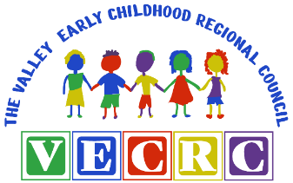

**School Readiness Liaison Report**

**February 2023**

Diana Brancato and Ayanna Williams

**OEC Updates:**

* **OEC ECE Reporter Data System-** The OEC has been working closely with their internal IT Department to ensure the transition from the Skylight partners to OEC went smoothly with minimal issues and/or disruptions. There is a new link for all to use as of January 9th. The enhancements made to the system include:
* Easier navigation throughout the application
* The ability to save reports while in the middle of inputting data
* The ability to quickly toggle students who are no longer enrolled
* The use of “pop-ups” when entering data for guidance
* Cosmetic changes as you log into this enhanced version
* **Enrollment Grant-** Quarter 2 applications had an extension date of February 3rd at no later than 11:59pm. OEC granted an extension due to the system having technical difficulties. Programs that are eligible to receive these funds per the guidance were asked to submit Q2 Enrollment-based grant applications by the deadline. After OEC set up Award Letters and budgets in eGMS, liaisons were provided with the grant amounts each program was eligible to receive following the completion of the 1st quarter. Liaisons requested invoices from programs so that payments could be sent.
* **Infant and Toddler Expansion spaces-** The OEC is inPhase 2whichsupports the creation of NEW full-day/full-year infant and toddler spaces in currently funded School Readiness and Smart Start program(s). Ayanna and Diana submitted the Qualtrics application on behalf of the Council for Ansonia, Derby, Seymour and Shelton to opt out as there is no capacity in the Valley School Readiness programs at this time. Phase 3 will be released at a future date and will be open to all licensed programs regardless of state-funded status.
* **Wage Supports for Early Childhood Educators-** This is a two-phased initiative for all School Readiness staff in licensed and license exempt programs. OEC is giving these funds directly to programs for each eligible staff member via an application process. All full-time staff will receive $1,000 and part-time staff will receive $400.00. OEC is also providing an additional 10% on top of staff payments to help with administrative processing costs. OEC hopes that this initiative helps with the support and recruitment of staff.

**Liaison Monitoring**:

* + Our third round of FY23 monitoring for Ansonia, Derby, Seymour and Shelton consisted of the Professional Registry check (Staff qualifications, DQSM compliance, licensing and accreditation status, Registry updates and reporting requirements) and a Review of each of the School Readiness classroom’s Learning Experience Plans (LEP’s). Each program was provided with a Monitoring Summary report, indicating meeting compliance or a need for a corrective action plan.

**Provider Meetings**:

* + Ayanna and Diana have a combined School Readiness Provider meeting planned for the month of February. The exact date is to TBD as OEC has not released School Readiness and Quality Enhancement Grant RFP documentation and guidance as of yet.

**School Readiness Providers**

Tracy- *Ansonia Public Schools*

*Diana Brancato shared out; staffing is a challenge;*

Shannon- *Julia Day Nursery*

Aly Stanisci- *Lower Naugatuck Valley EC Ed (TEAM)*

Barbara- *Valley YMCA Child Care Center*

Liz- *Kids Club (Seymour and Derby)*

Rebecca- *Shelton Public Schools* *Mohegan* and Shelton Public Schools Long Hill

**Valley Regional Adult Education**



**Valley Early Childhood Regional Council**

**February 2023**

**Enrollments*:**

Adult Basic Education (ABE) and General 47 students/76 enrollments

Education Development (GED)

Adult High School Credit Diploma Program 85 students/298 enrollments

(AHSCDP)

English as a Second Language (ESL) 113 students/135 enrollments

Citizenship 5 students

TOTAL 2022 – 2023 (To DATE): 246 students/510 enrollments

* Numbers reflect those students with 12+ hours in class (additional students are enrolled but have not yet attended for 12 hours)

**Speakers/Visit:**

* Post University
* Belle Academy of Cosmetology
* Naugatuck Valley Health District Information Table

**Program Highlights:**

* Strong registration numbers for all programs this school year
* Give away of Covid tests compliments of Naugatuck Valley Health District
* Offering a CPR class for students subsidized by VRAE

**Staff Development/Training/Meetings:**

* Guidance counselor will be a Career Navigator to support transition to postsecondary school and training
* Director attended grant meeting to support funding from the state
* Program Facilitator working on testing to capture best data for program
* Planning professional development for DEI for staff and instructors

**Child First**

**Valley Early Childhood Regional Committee (VECRC) Program Governance Report**

**Program**: Child First of the Parent Child Resource Center of BHCare (30 Elizabeth Street, Derby CT)

**Reporter**: Courtney Sherman, LCSW, Program Manager

**Reporting Period**: December 2022-February 2023

This has been a year of continued change for Child First at the Parent Child Resource Center of BHcare. The Child First staff have adjusted to new expectations of a new supervisor, and new expectations of our new funding source, DCF including major changes to data entry as required by the funders. We continue to address the ever-changing challenges of COVID-19 and continue to provide services via telehealth as needed, however have begun to move towards more in-person visits when safe for families and staff. In addition to these changes, the site is not fully staffed, and continues to work on recruitment to hire another clinician. Due to the lack of staffing, this has impacted the amount of families we can currently serve. Although not listed in the benchmarks below, we are currently serving 12 families and have 14 families on our wait-list. We are required by our funders to triage Child First services to families that are referred by DCF and have current DCF involvement. The site continues to strive towards meeting Child First NSO benchmarks.

Below please find the most recent Benchmark data as collected by Child First NSO, covering the performance of the site for the last few months. During this time our site continues to serve 100% of children in the 0-6 age range, and the site has increased the overall number of home visits and supervision hours for staff. In May 2022 the average number of visits for the clinician were 2.28 and by October 2022 were 6.52 (see adjusted home visits) for the clinician and by December 2022 have increased to 7.19 visits. The care coordinator’s home visits continue to increase monthly as well from 3.03 in November 2022 to 4.16 in December 2022. The supervision hours remain meeting the benchmark on a monthly basis. We are currently working on increasing home visits, and increasing early care mental health observations in early care sites that consent for Child First to complete an observation in the classroom setting. We are excited to be able to continue our work, providing clinical services and care coordination to the Valley’s youngest children to minimize stressors for caregivers so they can be more present for their child(ren), provide developmental guidance, make meaning of behavior, explore how history and feelings of caregivers impact their relationships with their child(ren), explore the effects of trauma on child development, support developmental delays, and grow capacity in caregivers to strengthen caregiver/child attachment.

|  |  |  |  |  |  |  |  |
| --- | --- | --- | --- | --- | --- | --- | --- |
| **Benchmark** | **Target** | **November 2022 Site Performance** | | | **December 2022 Site Performance** | | |
| **%** | **Numerator** | **Denominator** | | **%** | **Numerator** | | **Denominator** |
| **Age Served: 0-3 years** | 20-80% | No Admitted Clients | 0% | 0.00 | | 1 |
| **Age Served: 3-6 years** | 20-80% | No Admitted Clients | 100% | 1.00 | | 1 |
| **Adjusted Home Visit: Clinicians** *(Note: This Benchmark does not include the same activities as the Adjusted Direct Contacts Report. Please reference the "Services During COVID-19" tab for ADC Numbers)* | 90% | 56% | 6.76 | 12 | | 60% | 7.19 | | 12 |
| **Adjusted Home Visit: Care Coordinators** *(Note: This Benchmark does not include the same activities as the Adjusted Direct Contacts Report. Please reference the "Services During COVID-19" tab for ADC Numbers)* | 90% | 34% | 3.03 | 9 | | 46% | 4.16 | | 9 |
| **Meeting Identified Needs** | 60% | No Discharged Clients | | | No Discharged Clients | | |
| **Early Care Mental Health Observations/Consultations** | 90% | 13% | 1 | 8 | | 14% | 1 | | 7 |
| **Supervision Hours** | 75% | 109% | 15.25 | 14.00 | | 83% | 11.55 | | 14.00 |
| **Length of Service ≥ 6 months** | 70% | No Discharged Clients | | | No Discharged Clients | | |
| **Meeting Treatment Goals** | 60% | No Discharged Clients | | | No Discharged Clients | | |